Nepal College of Information Technology
Assessment
Fall 2010
Program: IT Time: 3 hrs
Semester: Fall (V) FM: 100
Subject: Signal System Processing PM: 50

The figures in the margin indicate full marks.
Attempt all the questions:
1 a) Find the Fourier Transform of the following signal. 5
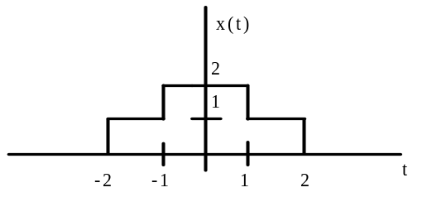
b) Prove whether the system y (n) = 5x (n) + 2 is linear or not. 5
c) Sketch the signal x (t) = A sin t. Also determine whether the given signal is power signal or an energy signal or neither. 5
2. a) Draw the magnitude response of Chebyshev I & Chebyshev II filter and compare them. 6
b) The following specification are given for Butterworth LPF 9
α_{max} = 0.5 dB dB f_{p} =1.59 khz
α_{min} = 20 dB dB f_{s} = o.318 khz
Determine:
i) Filter order.
ii) Location of poles & T (s).
iii) Half power frequency.
iv) Phase angle at w = 1 rad/ sec.
v) Quality factor (Q).
vi) Attenuation at w = 1500 rad/ sec.
3. a) Determine the particular solution of 1st order difference equation 6
y (n) + a₁ y (n-1) = x (n) , a₁ < 1
When the input signal x (n) is a unit step sequence.
b) Given the analog signal x_{a} (t) = 3cos 2000t + 5sin 6000t + 10cos 1200t. 9
i) Find Nyquist rate? If the signal is sampled at the rate f_{s} = 5000 samples / sec, what is discrete time signal obtained after sampling? What is folding frequency?
ii) What is the analog signal y_{a} (t) that can be reconstructed from the samples if we use ideal interpolation.
iii) Calculate no. of bit if each input sample is quantized into 512 different voltage levels. Also determine the resolution.
4. a) Compute the circular convolution between following two:
x₁ (n) = {1, 2, 1, 4} & x₂ (n) = {2, 1, 3}.
What is zero padding? 8
b) Given a sequence x (n) = {0, 1, 2, 3, 4, 5, 6, 7}. Determine X (k) using DIT FFT algorithm. 7
5. a) Find the inverse z-transform of 8
X(z) = 1 / ( 1 – 1.5 z⁻¹ + 0.5 z ⁻² )
i) ROC: z > 1
ii) ROC: z < 0.5
iii) ROC: 0.5 < z < 1
b) Given a three-stage lattice filter with coefficients k₁ = 1/2 , k₂ = 1/4, k₃ = 1/3, Determine the FIR filter coefficients for the Direct Form Structure. 7
6. a) A discrete time system is given as
y (n) = 0.7y (n-1) – 0.1y (n-2) + x (n).
i) Find system function H (z)?
ii) What is this system, FIR or IIR?
iii) Plot the magnitude response.
b) Explain the IIR filter design by Impulse Invariance Method and also indicate the relation between s-plane to z-plane. 8
7. Write short notes on (Any Two): 2*5=10
a) Matched Z-transform
b) Radix-2 FFT algorithm
c) FIR versus IIR filters

